CEN 4010 Principles of Software Engineering, Summer 2021

Team 1, Gopher

Team #1

Summer Poissonnier: Development Team [spoissonnier2019@fau.edu](mailto:spoissonnier2019@fau.edu)

Ania Schulz: Scrum Master [schulza2019@fau.edu](mailto:schulza2019@fau.edu)

Joshua Walsworth: Product Owner [jwalsworth2018@fau.edu](mailto:jwalsworth2018@fau.edu)

Rodrigue Bichotte: Development Team [rbichotte2018@fau.edu](mailto:rbichotte2018@fau.edu)

Carlos Alvarado: Development Team [calvarado2020@fau.edu](mailto:calvarado2020@fau.edu)

July 14, 2021

|  |  |  |
| --- | --- | --- |
| **Version** | **Date** | **Revision** |
| 1 | 6/14/2021 | N/A |
| 2 | 7/22/2021 | We took out the functions: Friends list and Suggested Friends list. |
|  |  |  |

**Milestone 4: Beta Launch and Reviews**

**Product Summary:**

1. Gopher
2. Here is the list of functions:
   1. You will be able to view and post comments on the main forum of the site
   2. You will be able to view and post messages within a discord link to a gopher discord.
   3. You will be able to create and edit your profile on Gopher
3. To be honest, there are so many similar sites out there that there are no functions Gopher has that are entirely unique. However, there is no site that has the exact combination of functions that Gopher does.
4. <https://lamp.cse.fau.edu/~cen4010_su21_g01/Gopher/>

<https://www.youtube.com/watch?v=pvn2Kyiupbk>

**Usability Test Plan:**

1. Test Objectives:

The objective of this test is to verify that the homepage does what it's intended to do. In the homepage we have a forum where people can post about a topic of their interest by submitting their email address, a topic title and the post. Once the user submits the post, it then takes you to a page where it shows you the topics in the forum, the number of posts, and where the user can also reply to a post of their choosing. The user can also select any post from the forum to see information such as the author, the post, the user can also reply to the post from there. To reply to a post the user must provide their email address, the post and submit it. These are the list of functions we intend to test.

1. Test plan:
2. System setup: HTML and CSS were used in the frontend (creating the design of the website with the help of bootstrap). For the backend we used PhpMyAdmin and MySQL so we can set up the database. The server was also used to help test the functionality of what was being done to the website (frontend and backend).
3. Starting point: A bootstrap was used as a starting point for the frontend of the website which was helpful but changes still had to be made like: a change in color, adding the forum, button for the functionality etc.
4. Task to be accomplished: The forum topic page still has to be updated in terms of looks (like adding color), adding buttons (to better the functionality of browsing from one page to another).
5. Intended user: This website is intended for anyone 16 and older trying to meet people/ make new friends/ chat with people with common interests.
6. Completion criteria: The forum’s topic pages match the rest of the website (colors, setup, etc.), the buttons (submit, add post, reply, etc.) work without any issues, going through the website from one page to another without any issues.
7. URL of the system to be tested: <https://lamp.cse.fau.edu/~cen4010_su21_g01/Gopher/>

3. Questionnaire form:

Here is the link to the questionnaire:

<https://docs.google.com/forms/d/e/1FAIpQLSflFMkdySRJwpG14Cz_RMYU9JL_it6vH7jRvNL2groN6OUouA/viewform?usp=sf_link>

For each of the questions below, please select the answer that best characterizes how you feel about the statement.

1. It's easy to post a topic in the forum

* Strongly agree
* Agree
* Neither agree nor disagree
* Disagree
* Strongly disagree

1. It's easy to reply to a post

* Strongly agree
* Agree
* Neither agree nor disagree
* Disagree
* Strongly disagree

1. It's easy to navigate through the pages

* Strongly agree
* Agree
* Neither agree nor disagree
* Disagree
* Strongly disagree

Q**A Test Plan:**

1. Test Objectives:

The objectives of the test are to verify and validate the software. The first objective is to ensure that the software is working the way it is intended to without error. The second objective is to ensure that the software is built correctly and matches the requirement specifications. The software should be able to allow the user to view the home page and use the discussion forum to communicate with and interact with other users.

1. Hardware and Software setup:

To develop the software, we are using HTML and CSS on the frontend using Bootstrap. Bootstrap provides us with a design that has already been implemented that we can use to develop the software. We then are using PHP and MySQL on the backend to connect the database to the software to ensure that the server and web page are able to communicate.

1. Feature to be tested:

The feature that is being tested is the home page which consists of a header with a navigation bar where the user can either go to their profile to change their settings, back to the home page, or to a chat room that consists of a discord link. The home page will contain a ‘Add a Topic’ discussion where the user can then enter their email address, the topic title, and then post the text that they would like to write on the forum. The user can then see what topics have been posted on the forum and choose to respond to a topic if they want to. If the user does not want to then they can go back to the home page.

1. Actual test cases:
   1. **Test Case 1:** In this test case, the user (which is me) went to the Gopher homepage on Google Chrome. On the Gopher homepage, the user was able to enter their email address, their topic of choice, and their text they wanted to display on the homepage. The user created a topic called ‘Test 1’ and wrote ‘This is test 1’. The user is then directed to a page letting them know that their topic was added to the forum and they can either view the forum or go back to the home page. The user then went to the forum and was able to see all of the topics and posts in the forum. The user was given the option to add another topic/go back to the homepage.
   2. **Test Case 2:** In this test case, the user went to the Gopher homepage on the Firefox Browser. On the Gopher homepage, the user was able to enter their email address, topic of choice, and text to display on the homepage. The user created a topic called ‘Test 2’ and wrote ‘This is test 2’. The user is then directed to a page letting them know that their topic was added to the forum and they can either view the forum or go back to the home page. The user then went to the forum and was able to see all of the topics and posts in the forum. The user was given the option to add another topic/go back to the homepage or click on the topic and reply to the user’s post.
   3. **Test Case 3:** In this test case, the user went to the Gopher homepage on the Google Chrome Browser. On the Gopher homepage, the user was able to enter the email address, topic, and text. The user created a topic called ‘Test 3’ and wrote ‘This is test 3’. The user is then directed to a page letting them know that their topic was added to the forum and they can either view the forum or go back to the home page. The user then went to the forum. The user was given the option to add another topic/go back to the homepage or reply to the user’s post.

|  |  |  |  |  |  |
| --- | --- | --- | --- | --- | --- |
| **Test #** | **Test Title** | **Test Description** | **Test Input** | **Expected Correct Output** | **Test Results** |
| 1 | Homepage on Google Chrome | This test is a test of the home page functionality on the web browser, Google Chrome. | Users will input their email, topic, and text to the forum. | It is expected that the user will be able to see their forum topic. | Pass |
| 2 | Homepage on Firefox | This is a test of the home page functionality on the web browser, Firefox. | Users will input their email, topic, and text to the forum and reply to others. | It is expected that the user will be able to see their forum topic and respond to others on the forum. | Pass |
| 3 | Homepage on Google Chrome | This is the second test of the home page functionality on the web browser, Google Chrome | Users will input their email, topic, and text to the forum and reply to others. | It is expected that the user will be able to see their forum topic and respond to others on the forum. | Pass |

**Code Review:**

The chosen coding style was HTML5 and PHP while using Brackets as the platform to develop the code in and Bootstrap to help with the design of Gopher.

**Example of the code/Comments:**

<?php

//this checks for required fields from the form

if ((!$_POST['topic_owner']) || (!$_POST['topic_title'])

|| (!$_POST['post_text'])) {

header("Location: index.html");

exit;}

//this is to connect to server and select database

$conn = mysqli_connect("lamp.cse.fau.edu", "cen4010_su21_g01", "JNc72QcBEM", "cen4010_su21_g01")

or die(mysqli_error());

//create and issue the first query

$add_topic = "insert into Forum_topics values ('', '$_POST[topic_title]',

now(), '$_POST[topic_owner]')";

mysqli_query($conn, $add_topic) or die(mysqli_error($conn));

//get the id of the last query

$topic_id = mysqli_insert_id($conn);

//create and issue the second query

$add_post = "insert into Forum_posts values ('', '$topic_id',

'$_POST[post_text]', now(), '$_POST[topic_owner]')";

mysqli_query($conn, $add_post) or die(mysqli_error($conn));

//create nice message for user

$msg = "<P>The topic has been created.</p>";

?>

<html>

<head>

<title>New Topic Added</title>

</head>

<body>

<h1>New Topic Added</h1>

<?php print $msg; ?>

<p>Would you like to <a href="index.html">add another topic</a>?</p>

<p>Would you like to <a href="topiclisting.php">go to the forum</a>?</p>

</body>

</html>

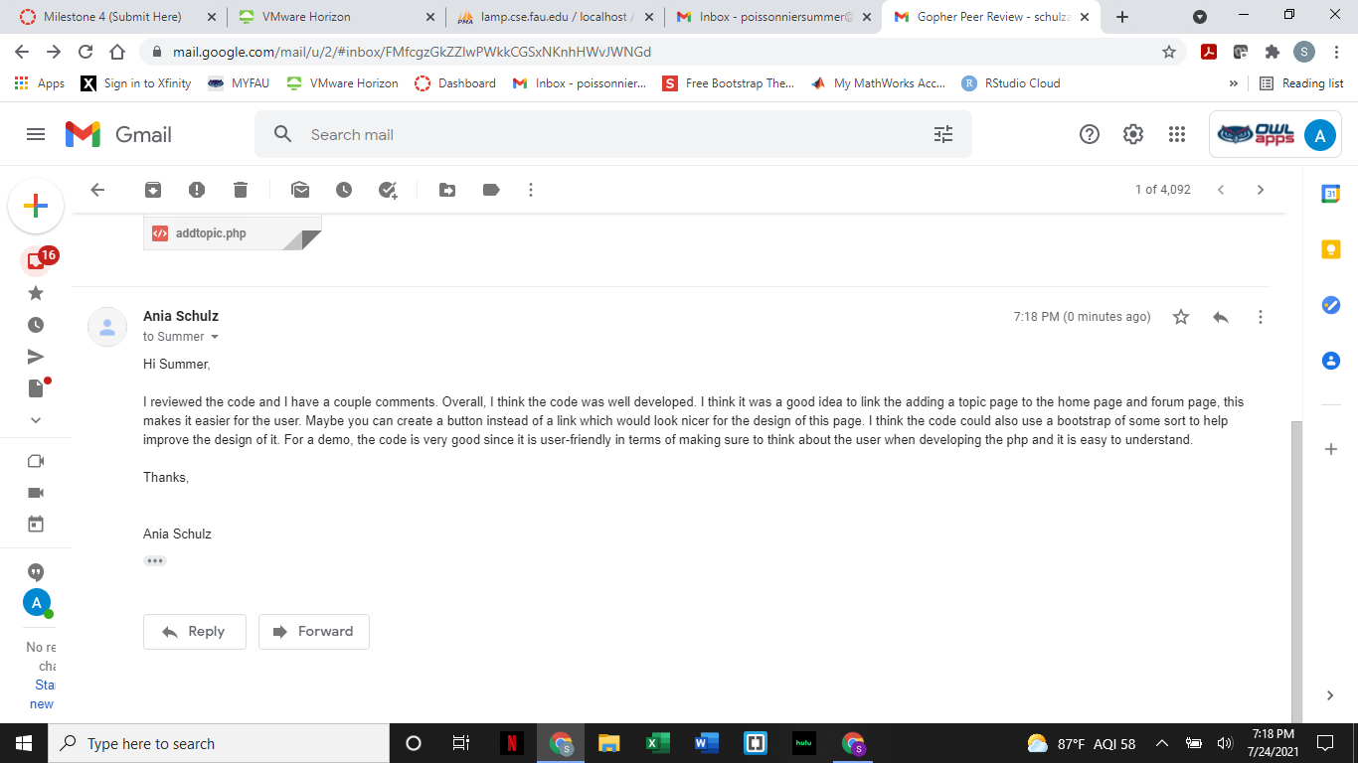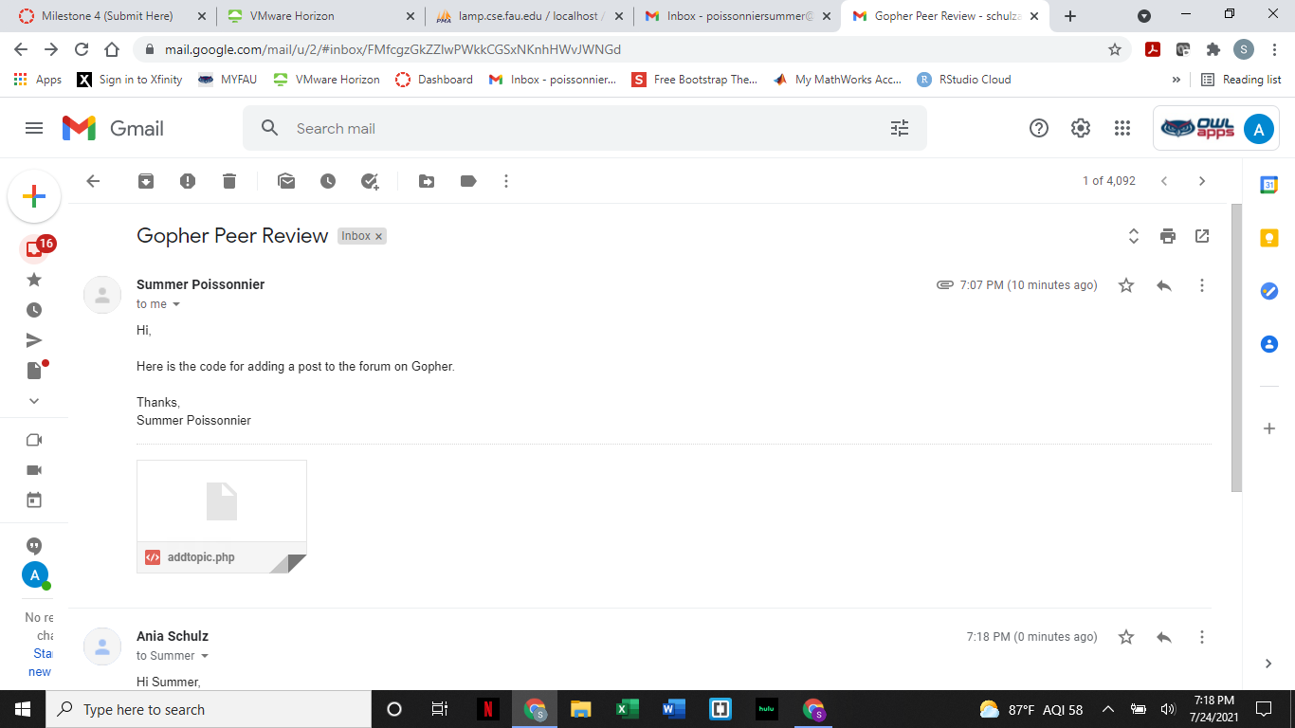

**Self-Check for Security [Carlos]:**

There are currently two proposed security systems for the user’s data (the group is still debating which one to implement). The main data assets we aim to protect are the user’s username and password. For the 1st proposed system the username and password will be encrypted using a simple Caesar cypher and stored separately in the database. Whenever the user enters their username, their input will be encrypted and a script will go through the encrypted usernames in search for a match. Once a match is found, the user’s password will be searched in the same corresponding file that stores passwords and then compares it to the user’s inputted password. No unencrypted username and password data will be stored in the database. The second option is to encrypt the username file and password file using the crypt php extension which will function in a similar manner to the 1st option, however the entire file will be read and decrypted whenever the user is inputting their information in order to login to the site.

User inputs in the search bar will be validated, any interest or website function that is defined will yield a result. Any user input that is not defined will return an error message. Invalid usernames and passwords will also yield error messages. The site will use built-in form validation via html5.

**Self-Check Adherence to original Non-functional specs:**

|  |  |  |  |
| --- | --- | --- | --- |
| **Non-functional**  **Spec** | **Spec** | **Spec Description** | **Status** |
| 1 | Performance | System response time of 2 to 5 seconds | DONE |
| 2 | Security | Login. Username & password authentication. | ON TRACK |
| 3 | Usability | User-friendly design.  Everything is easy for the user to find. | DONE |
| 4 | Availability | Available any time the user needs, unless going through maintenance. | ON TRACK |
| 5 | Accessibility | Website will be accessible from major web-browsers, laptops and mobile devices. | ON TRACK |
| 6 | Expected Load | No bigger implementation than at a university level, no more than a thousand users. | ON TRACK |
| 7 | Storage | Usernames, email and passwords will be stored in database | DONE |